**Assignment no. 6**

**Roll no.: 33207**

Title : Page Replacement Algorithms

**AIM**: Implement the C program for Page Replacement Algorithms: FCFS, LRU, and Optimal for frame size as minimum three.

**OBJECTIVE**:

This assignment helps the students understand the Page Replacement Algorithms in Unix/Linux and how to implement it in C

**THEORY**:

What are PAGE REPLACMENT Algorithms?

As studied in Demand Paging, only certain pages of a process are loaded initiallyinto the memory. This allows us to get more processes into memory at the same time. But what happens when a process requests for more pages and no free memory is available tobring them in. Following steps can be taken to deal with this problem:

1. Put the process in the wait queue, until any other process finishes its executionthereby freeing frames.

2. Remove some other process completely from the memory to free frames. 3. Find some pages that are not being used right now, move them to the disk to get free frames. This technique is called Page replacement and is most commonly used. 4.

In this case, if a process requests a new page and supposes there are no free frames, thenthe Operating system needs to decide which page to replace. The operating systemmust use any page replacement algorithm in order to select the victim frame. The Operatingsystem must then write the victim frame to the disk then read the desired page into theframe and then update the page tables. And all these require double the disk access time.

1. Page replacement prevents the over-allocation of the memory by modifying thepage-fault service routine.

2. To reduce the overhead of page replacement a modify bit (dirty bit) is used in order to indicate whether each page is modified.

3. This technique provides complete separation between logical memory and physical memory.

**Page Replacement in OS**

In Virtual Memory Management, Page Replacement Algorithms play an important role. The main objective of all the Page replacement policies is to decrease the maximumnumber of page faults.

**Page Fault –** It is basically a memory error, and it occurs when the current programs attempt to access the memory page for mapping into virtual address space, but it is unableto load into the physical memory then this is referred to as Page fault.

**Basic Page Replacement Algorithm in OS**

Page Replacement technique uses the following approach. If there is no free frame, then wewill find the one that is not currently being used and then free it. A-frame can be freedbywriting its content to swap space and then change the page table in order to indicate that thepage is no longer in the memory.

1. First of all, find the location of the desired page on the disk.

2. Find a free Frame: a) If there is a free frame, then use it. b) If there is no free framethen make use of the page-replacement algorithm in order to select the victimframe. c) Then after that write the victim frame to the disk and then make thechanges in the page table and frame table accordingly.

3. After that read the desired page into the newly freed frame and then change thepage and frame tables.

4. Restart the process.

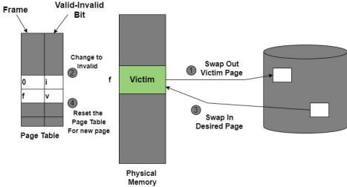Figure: Page Replacement

**Page Replacement Algorithms in OS**

This algorithm helps to decide which pages must be swapped out from the main memoryinorder to create a room for the incoming page. This Algorithm wants the lowest page-fault rate.

Various Page Replacement algorithms used in the Operating system are as follows; 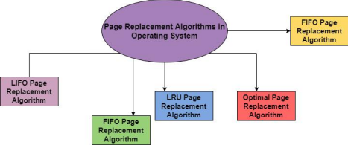Let us discuss all algorithms one by one in the upcoming sections:

**1. FIFO Page Replacement Algorithm**

It is a very simple way of Page replacement and is referred to as First in First Out. This algorithm mainly replaces the oldest page that has been present in the main memory for thelongest time.

This algorithm is implemented by keeping the track of all the pages in the queue. As new pages are requested and are swapped in, they are added to the tail of a queue andthe page which is at the head becomes the victim.

This is not an effective way of page replacement but it can be used for small systems.

**Advantages**

This algorithm is simple and easy to use.

FIFO does not cause more overhead.

**Disadvantages**

This algorithm does not make the use of the frequency of last used time rather it just replaces the Oldest Page.

There is an increase in page faults as page frames increases.

The performance of this algorithm is the worst.

**Example:**

A system uses 3 page frames for storing process pages in main memory. It uses the First inFirst out (FIFO) page replacement policy. Assume that all the page frames are initially empty. What is the total number of page faults that will occur while processing the page reference string given below-

4 , 7, 6, 1, 7, 6, 1, 2, 7, 2

Also calculate the hit ratio and miss ratio.

Solution-

Total number of references = 10

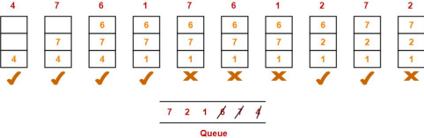From here,

Total number of page faults occurred = 6

Calculating Hit ratio-

Total number of page hits

= Total number of references – Total number of page misses or page faults = 10 – 6

= 4

Thus, Hit ratio

= Total number of page hits / Total number of references

= 4 / 10

= 0.4 or 40%

Calculating Miss ratio-

Total number of page misses or page faults = 6

Thus, Miss ratio

= Total number of page misses / Total number of references

= 6 / 10

= 0.6 or 60%

**Alternatively**,

Miss ratio

= 1 – Hit ratio

= 1 – 0.4

= 0.6 or 60%

**2. LRU Page Replacement Algorithm in OS**

This algorithm stands for "Least recent used" and this algorithm helps the Operating systemto search those pages that are used over a short duration of time frame. The page that has not been used for the longest time in the main memory will be selected for replacement.

This algorithm is easy to implement.

This algorithm makes use of the counter along with the even-page.

**Advantages of LRU**

It is an efficient technique.

With this algorithm, it becomes easy to identify the faulty pages that are not neededfor a long time.

It helps in Full analysis.

**Disadvantages of LRU**

It is expensive and has more complexity.

There is a need for an additional data structure.

**Example:**

A system uses 3 page frames for storing process pages in main memory. It uses the Least Recently Used (LRU) page replacement policy. Assume that all the page frames are initially empty. What is the total number of page faults that will occur while processing the page reference string given below-

4 , 7, 6, 1, 7, 6, 1, 2, 7, 2

Also calculate the hit ratio and miss ratio.

Solution-

Total number of references = 10

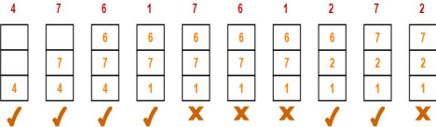

From here,

Total number of page faults occurred = 6

In the similar manner as above-

Hit ratio = 0.4 or 40%

Miss ratio = 0.6 or 60%

**3. Optimal Page Replacement Algorithm**

This algorithm mainly replaces the page that will not be used for the longest time in the future. The practical implementation of this algorithm is not possible. Practical implementation is not possible because we cannot predict in advance thosepages that will not be used for the longest time in the future.

This algorithm leads to less number of page faults and thus is the best-known algorithm

Also, this algorithm can be used to measure the performance of other algorithms.

**Advantages of OPR**

This algorithm is easy to use.

This algorithm provides excellent efficiency and is less complex.

For the best result, the implementation of data structures is very easy

**Disadvantages of OPR**

In this algorithm future awareness of the program is needed. Practical Implementation is not possible because the operating systemis unable totrack the future request

**Example:**

A system uses 3 page frames for storing process pages in main memory. It uses the Optimal page replacement policy. Assume that all the page frames are initially empty. What is the total number of page faults that will occur while processing the page reference string givenbelow-

4 , 7, 6, 1, 7, 6, 1, 2, 7, 2

Also calculate the hit ratio and miss ratio.

Solution-

Total number of references = 10

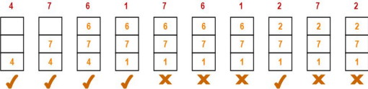

From here,

Total number of page faults occurred = 5 In the similar manner as above-

Hit ratio = 0.5 or 50% Miss ratio = 0.5 or 50%